HandsMen Threads: Elevating the Art of Sophistication in Men's Fashion

# 1. Abstract

HandsMen Threads is a Salesforce-based project designed to revolutionize the management of men's fashion retail operations. The project leverages Salesforce's CRM capabilities with custom applications, objects, automation flows, and Apex triggers to streamline business processes including customer management, product inventory, order processing, marketing, and loyalty programs. It provides a comprehensive solution to enhance operational efficiency, customer engagement, and data-driven decision-making in the fashion industry.

# 2. Objective

The objectives of the HandsMen Threads project are as follows:

• Build a custom Salesforce application tailored to a men's fashion business model.

• Create custom objects to manage customers, products, inventory, and orders effectively.

• Implement automation through flows for order confirmation, stock alerts, and loyalty programs.

• Develop validation rules to ensure data integrity and enforce business logic.

• Integrate Apex triggers to manage order totals and inventory stock deduction automatically.

• Use dashboards and reports for real-time data visualization and strategic planning.

# 3. Technology Description

**Salesforce Developer Org**

• A Salesforce Developer Org is a free, fully-featured Salesforce environment provided to developers for learning, building, and testing applications.  
• It includes standard CRM functionalities along with customization capabilities to build tailored apps.  
• This org serves as the workspace for creating the HandsMen Threads project.

**Custom Object Tabs**

• Custom object tabs provide a user-friendly interface to access and manage data stored in custom objects.  
• In HandsMen Threads, custom object tabs were created for HandsMen Customers, HandsMen Products, HandsMen Orders, and Inventories.  
• These tabs allow direct navigation to specific data sets and help streamline business workflows.

**Custom Lightning App**

• A Lightning App is a collection of tabs, objects, and components bundled for a specific business need.  
• The HandsMen Threads Lightning App centralizes all related objects like Customers, Products, Orders, and Reports.  
• It improves user efficiency by keeping relevant functionalities in one place.

**Profiles and Roles**

• Profiles control what users can do (permissions) while roles control what data they can see in the hierarchy.  
• Specific profiles were created to grant appropriate CRUD permissions for custom objects.  
• Roles ensure that managers have visibility over their team’s data, while standard users have restricted access.

**Permission Sets**

• Permission Sets extend a user’s functional access without altering their profile.  
• They were used to give special access for creating or editing sensitive records like Inventories or Orders.  
• This allows flexibility in granting temporary or additional permissions to specific users.

**Validation Rules**

• Validation rules enforce data quality by preventing incorrect or incomplete data from being saved.  
• Example: The HandsMen Customer object requires an email address to be entered when creating a new customer record.  
• This ensures business processes are not disrupted by incomplete records.

**Email Templates and Email Alerts**

• Email templates standardize outgoing communication, ensuring professional and consistent messaging.  
• In this project, templates were created for Order Confirmation and Low Stock Alert emails.  
• Email alerts were set up to automatically trigger these templates when certain conditions are met (e.g., order creation or low inventory).

**Flows (Order Confirmation, Stock Alert, Loyalty Program)**

• Order Confirmation Flow: Automatically sends a confirmation email to customers upon successful order creation.  
• Stock Alert Flow: Notifies the inventory manager when product stock drops below a set threshold.  
• Loyalty Program Flow: Rewards loyal customers based on purchase history, generating loyalty points and sending notifications.

**Apex Triggers**

• Apex triggers allow custom actions to be executed before or after records are inserted, updated, or deleted.  
• Order Total Trigger: Calculates the total amount for an order based on product price and quantity.  
• Stock Deduction Trigger: Automatically updates inventory levels when an order is confirmed, reducing the stock quantity accordingly.

# 4. Detailed Execution of Project Phases

**4.1 Developer Org Setup**

A Salesforce Developer Org was created using the following link:

<https://developer.salesforce.com/signup>

The account was verified and set up for project development

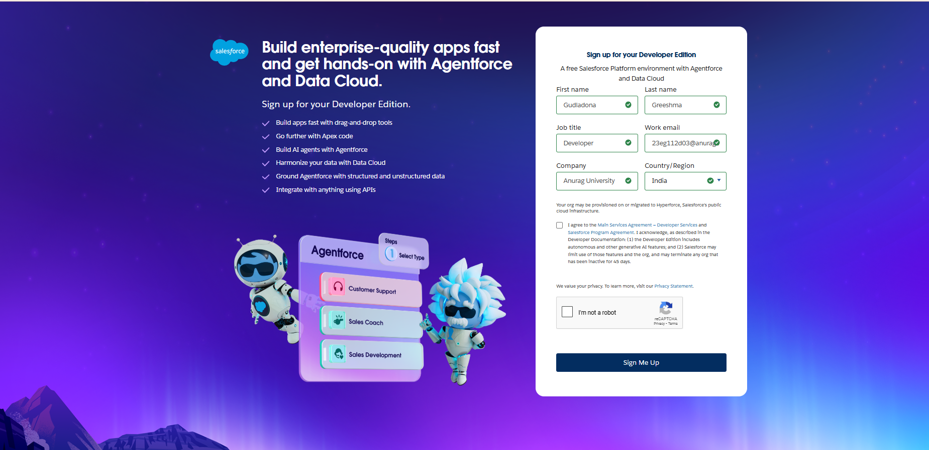

**4.2 Create Custom Objects**

Custom objects such as HandsMen Customers, HandsMen Products, Inventories, Orders, Marketing Campaigns were created to manage all business operations.

**4.3 Create Lightning App**

A custom Lightning App was created to unify all custom objects and features into a single interface for easy navigation.

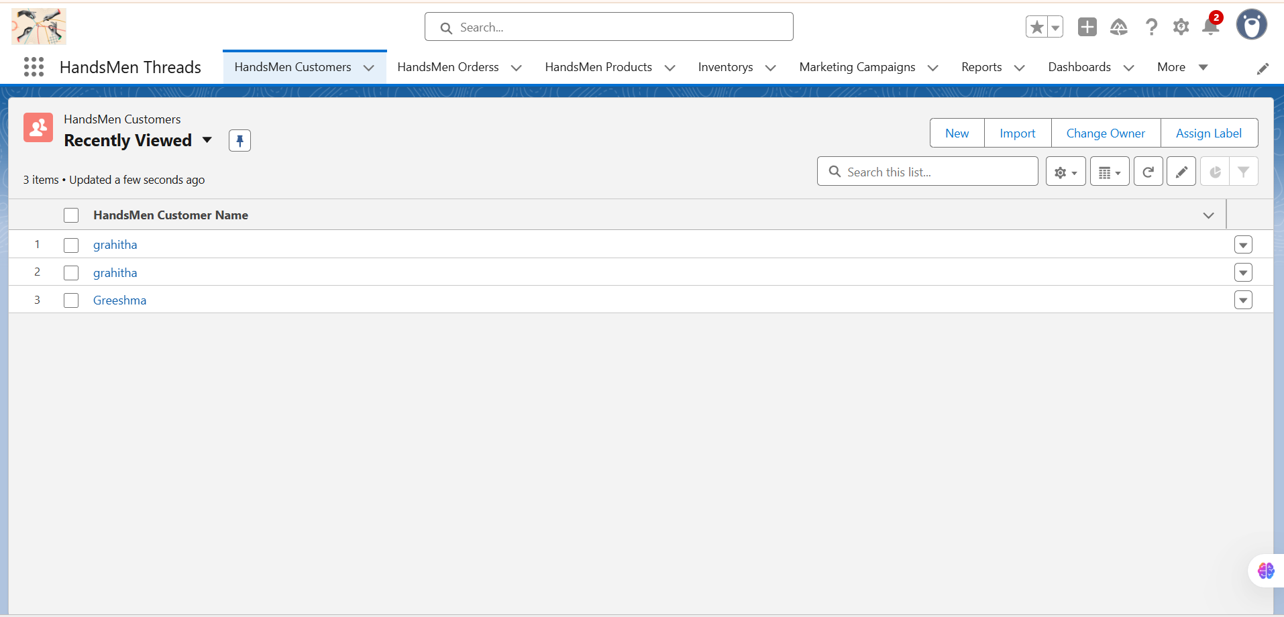

**4.4 Validation Rules**

Validation rules were implemented to enforce required data input, such as ensuring email is provided for customers.

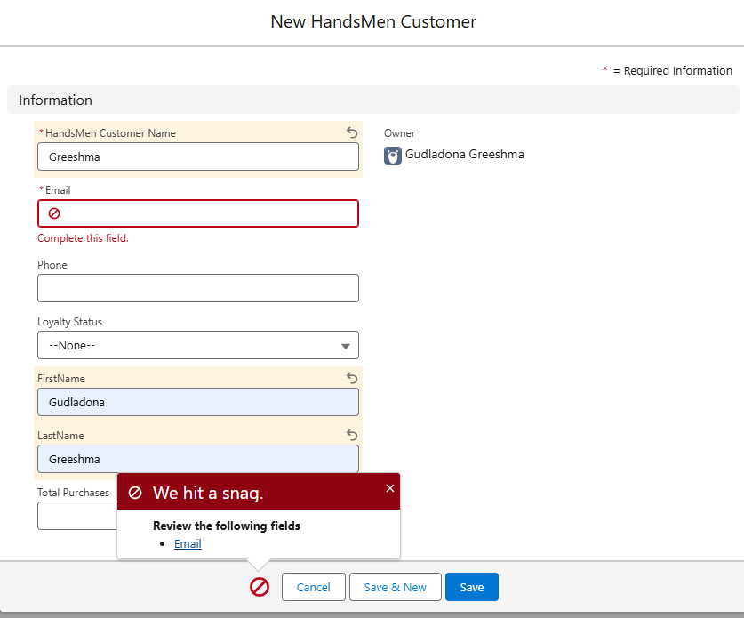

Here we hit a snag because we did not enter the email, after entering the email the snag will go.

**4.5 User Roles and Profile Settings**

Defined roles and profiles to control data access and permissions within the organization.

**4.6 User Creation**

Users were created and assigned appropriate roles and profiles to manage their access and functionalities.

**4.7 Email Templates and Alerts**

Email templates and alerts were configured for automated notifications.

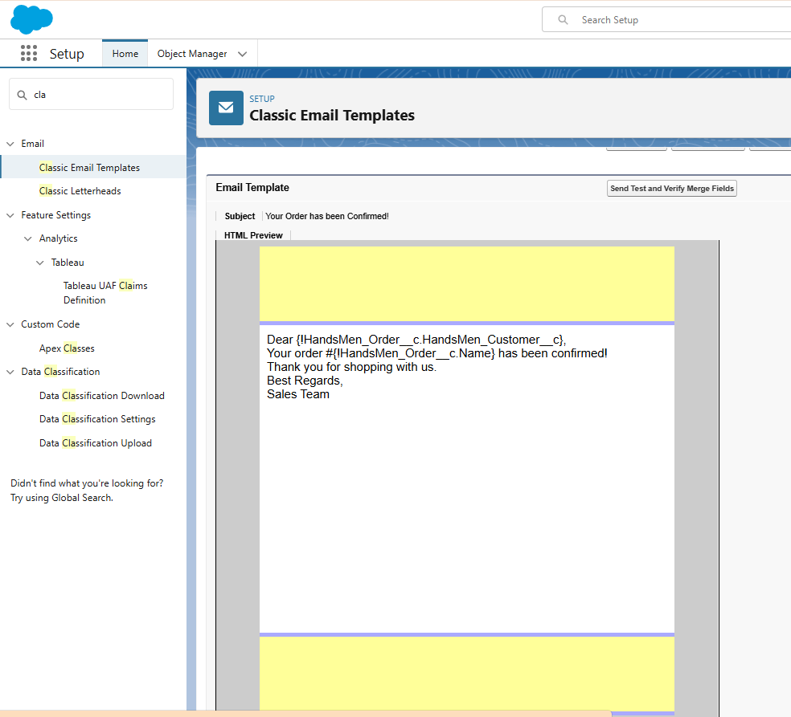

**4.8 Flow Implementation**

Flows were created to automate processes:

• Order Confirmation Flow: Sends confirmation email upon order creation.

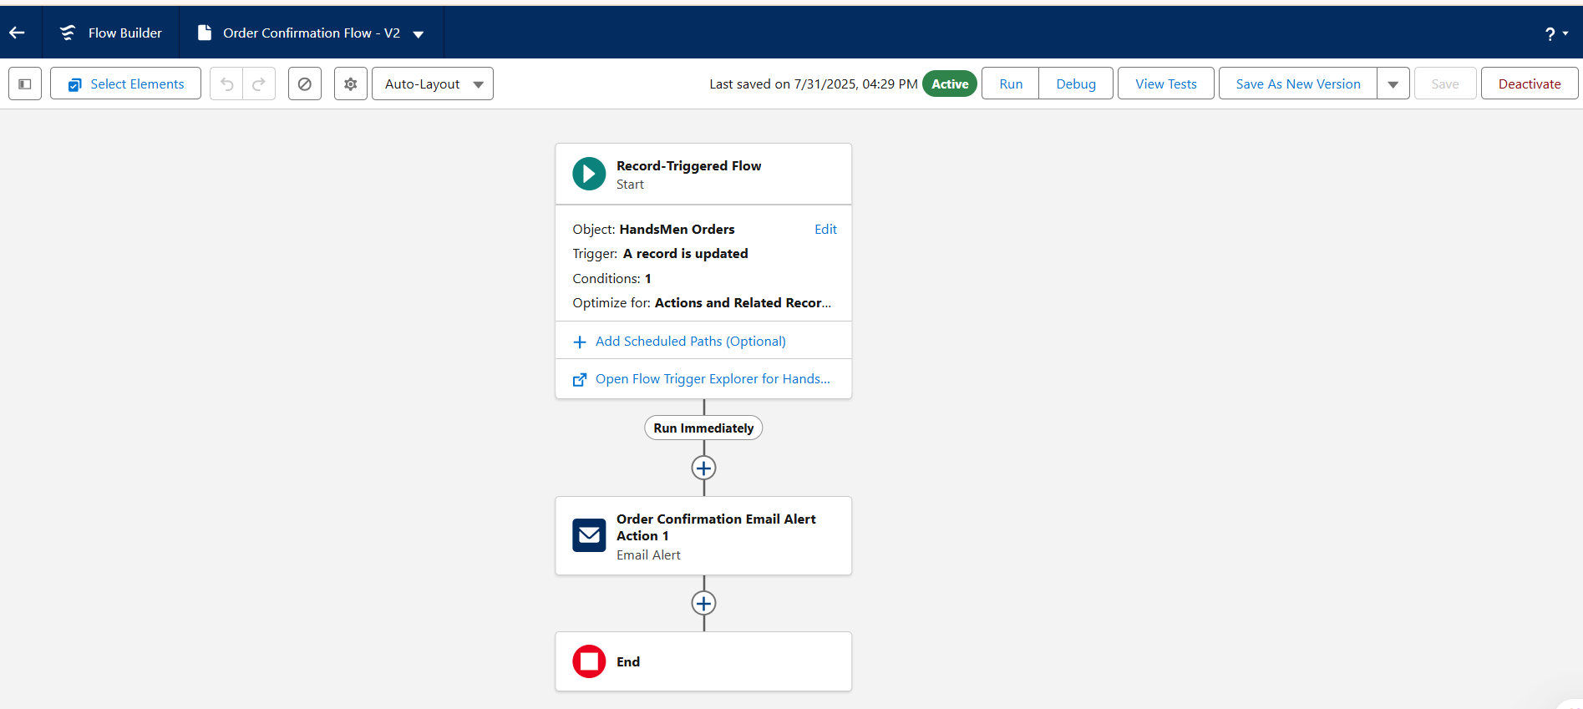

• Low Stock Alert Flow: Sends low-stock notification email.

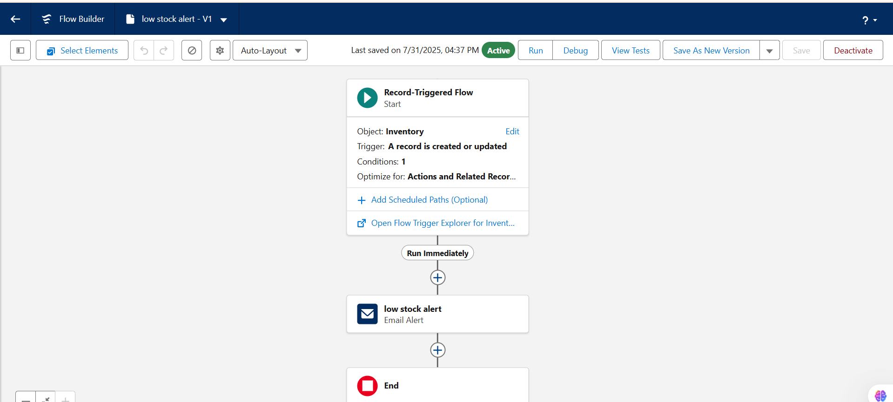

• Loyalty Program Flow: Rewards customers for repeat purchases.

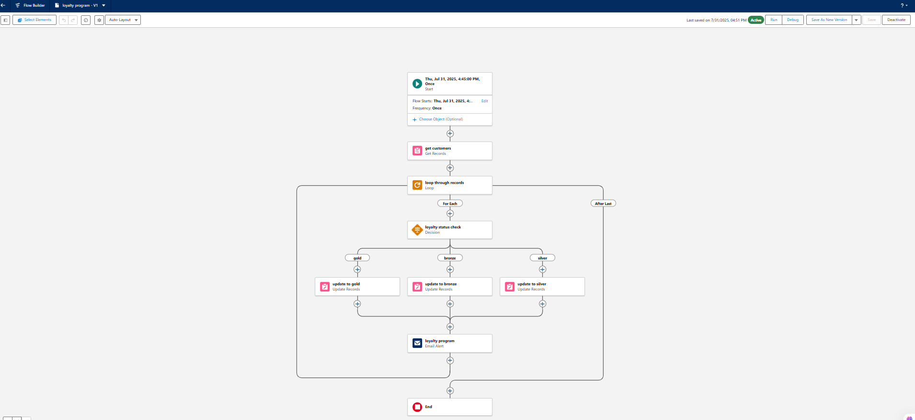

**4.9 Apex Triggers**

• Apex triggers allow custom actions to be executed before or after records are inserted, updated, or deleted.  
• Order Total Trigger: Calculates the total amount for an order based on product price and quantity.  
• Stock Deduction Trigger: Automatically updates inventory levels when an order is confirmed, reducing the stock quantity accordingly

**5. Project Explanation – Real-World Example**

**5.1 Customer Registration**

• New customer Greeshma visits store or website.  
• Record created in HandsMen Customer object with name, phone, and email (23eg112d03@anurag.edu.in).  
• Validation Rule ensures email format is correct.  
• Loyalty status set to Bronze.

**5.2 Product Setup**

• Admin adds products like T-shirts, Jeans, Jackets into HandsMen Product object.  
• Example: T-shirt, Price: $1,200, Stock: 600.  
• Inventory record created to manage stock levels.

**5.3 Order Placement**

• Greeshma purchases 500 T-shirts.  
• Order O-0001 created with total amount $600,000.  
• Status marked as Confirmed.

**5.4 Inventory Update**

• Apex Trigger deducts purchased quantity from inventory.  
• Stock reduced from 600 to 100.  
• Inventory status remains Available.

**5.5 Loyalty Program**

• Loyalty points awarded based on purchase value.  
• $600,000 purchase increases potential loyalty tier.

**5.6 Email Notifications**

• Order confirmation email sent to customer.  
• Low stock alert sent to inventory manager if threshold reached.

**5.7 Users and Roles**

• Admins manage all records.  
• Sales reps create customers and orders.  
• Managers have visibility over all data.

**Screenshots**

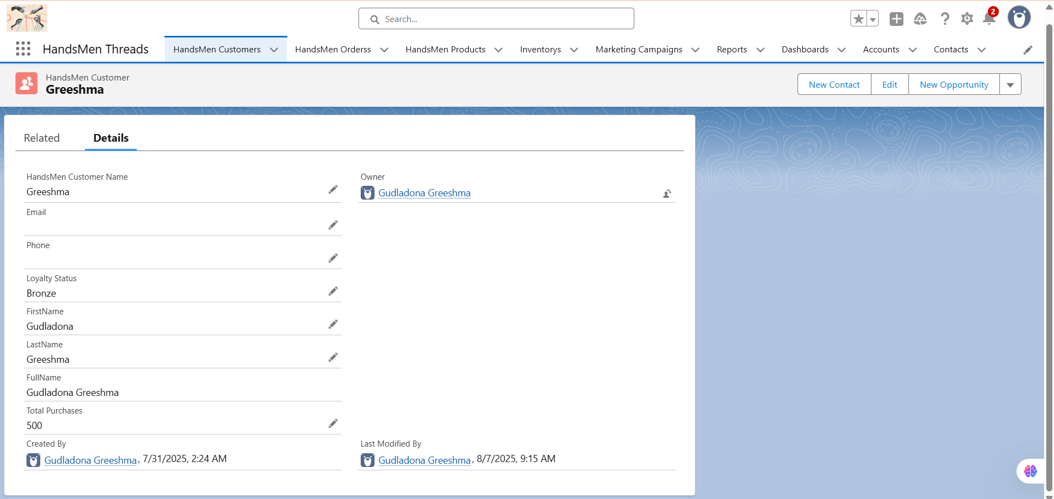

**Fig: Customer creation in HandsMen Threads**

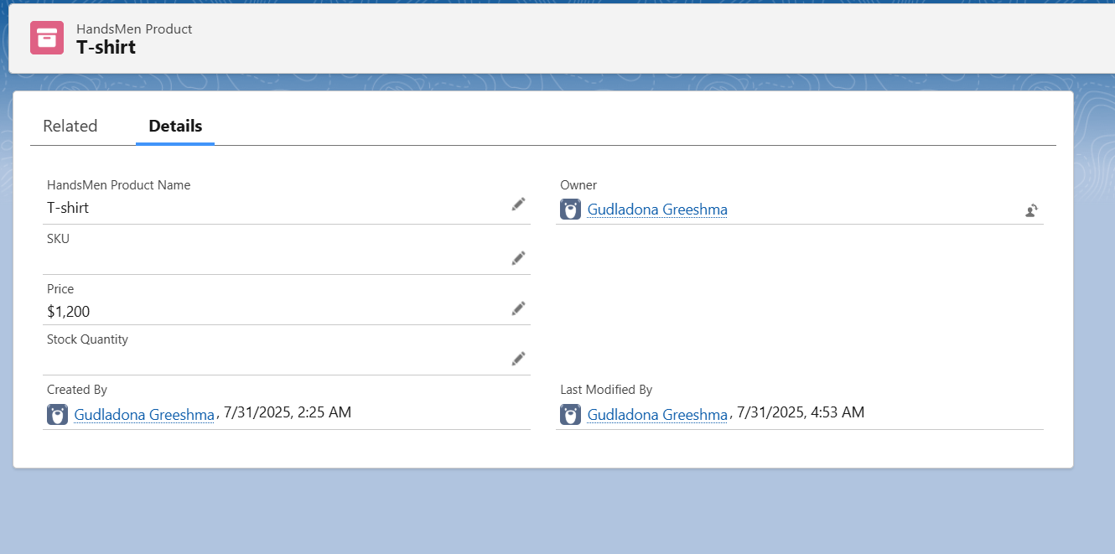

**Fig: Products in HandsMen Threads**

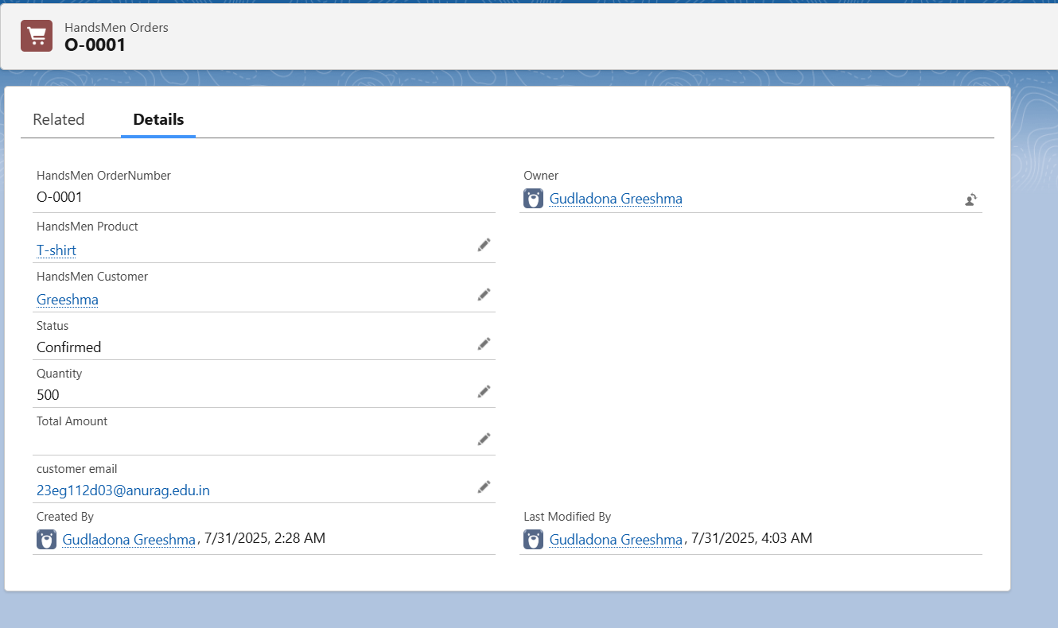

**Fig: Order confirmation**

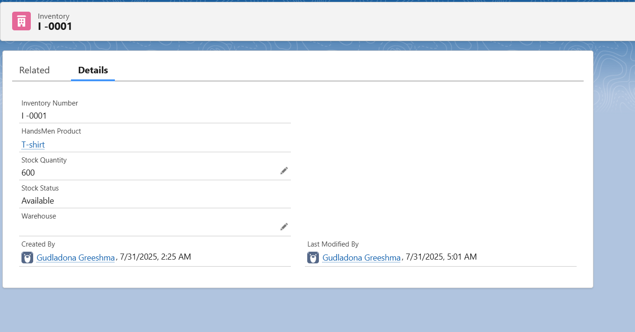

**Fig: Inventory**

# 6. Conclusion

Hans Men Threads demonstrates the versatility and power of Salesforce in managing end-to-end retail operations. By integrating custom objects, validation rules, flows, and triggers, the project streamlines processes, improves customer engagement, and provides actionable insights. This solution is adaptable to various retail domains beyond men's fashion